ACKNOWLEDGEMENT

We would like to express our thanks of gratitude to our HOD Ms. Anupam Singh who gave us the golden opportunity to do this wonderful project ElectroRetailer, Which also helped us in doing a lot of Research We came to know about so many new things, we are thankful to them.
We also take this opportunity to express deep gratitude to ARCADE BUSINESS COLLEGE. We would like to thank our friends and family for the support and encouragement they have given us during the course of our work.
Next, we thank our respectable parents for educating us with aspects from both arts and science, for their unconditional support and encouragement to pursue our interests, even when interests went out of bounds.
We cannot forget our Teams & Lab teacher in the faculty of Computer Science & Engineering for the academic interactions and Ideas. We must thank and acknowledge our college, Arcade Business College. Next, we thank our respectable parents for educating us with aspects from both arts and science, for their unconditional support and encouragement to pursue our interests, even when interests went out of bounds.
DECLARATION

We Amit Narayan, Saloni Kumari, Ashish Kumar, and Ayush Pandey a student of the Bachelor of Computer Application (BCA) do hereby declare that ElectroRetailer is done by us under the guidance of Ms. Anupam Singh. We are creating the project as per the college’s rules and regulations. All information provided and work done is completely genuine and is not copied from any online or offline platform.

Thank You
Supervised By:

…………………………
Anupam Singh
HOD of BCA
Arcade Business College

Co-Supervised By:

…………………………
Mr. Rahul Kumar Singh
Lab Faculty
Arcade Business College

Arcade Business College

Submitted By:

……………………
Amit Narayan [Team Leader]

…………………….
Saloni Kumari

…………………….
Ashish Kumar

…………………….
Ayush Pandey
TABLE OF CONTENT
- Introduction 5
- Limitations of the existing system 7
- Objective of project 8
- Hardware and Software requirements 9
- Introduction to Visual Basic 6.0 10
- Oracle 10g 12
- Module Description 15
- E – R Diagram 17
- Table Description 18
- Project planning 28
- Future Scope of Project 29
INTRODUCTION (About Organization)

Here, I am talking about an electronic store whose name is Spice Hot Spot. This store was opened in 2015 by Harsh Raj. This store sells many electronic items like televisions, refrigerators, washing machines, mobiles, etc., with more than fifteen employees. In this store, they are managing their records on paper.
When they order some goods for sell. They have to maintain order-related data (like supplier details, product details, payment details, and purchase details) in different registers. Entering so many details took lots of time. It also causes data redundancy, meaning they must maintain the same data in registers. At the time of order receiving, they will have to check order details to verify goods quantities. After receiving the product, they have to maintain their product relate details (like stock details, product receiving details, and purchase invoices).
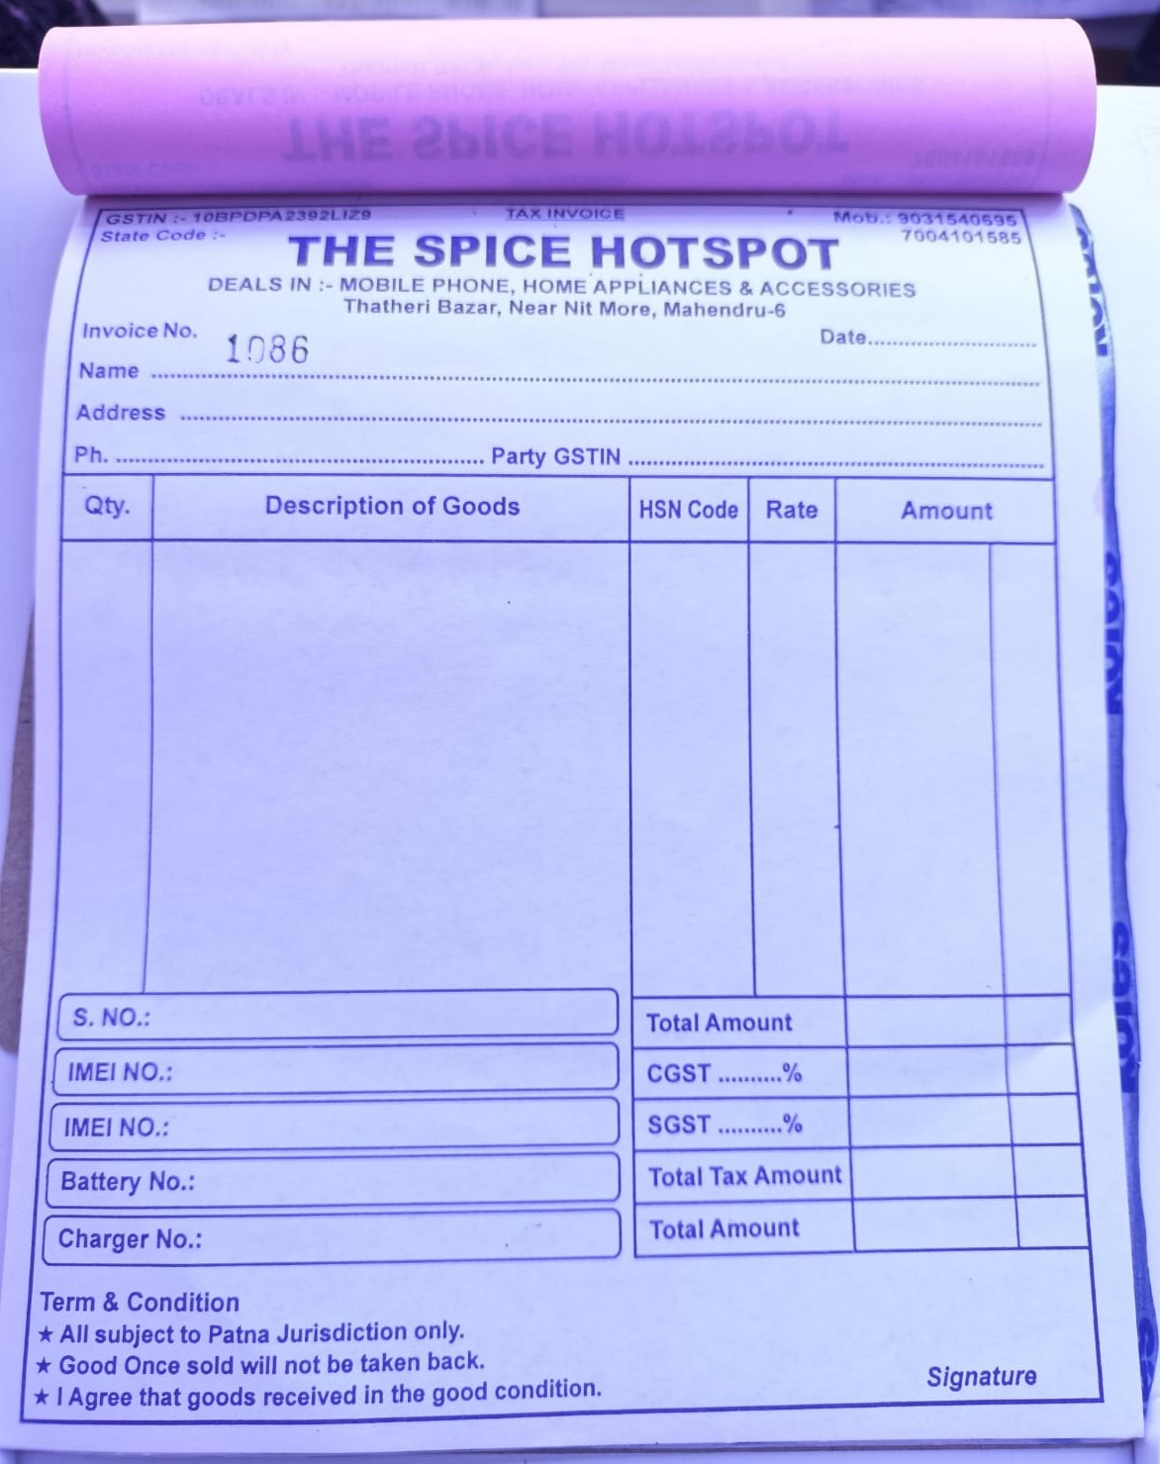
When a customer purchases some goods then they give a handwritten invoice. After that, they have to maintain their register (like customer details, product details, invoice details, transaction details, and stock details). Due to some product defect, the Customer wants to Exchange or return the product. For this reason, they have to rewrite a new exchange or return invoice with the same afford.
If we talk about employees, they maintain three types of records: employee details, wages, and attendance. Attendances are managed on daily basis. And their wages are managed on monthly basis. Employee details are managed at the time of joining.
Here we are talking about supplier-related details such as supplier details, purchase details (supplier-wise), purchase return details, and payment details.
They also maintain customer records such as their name, mobile, address, GST number (optional), purchase details, and product details.
Here I am talking about one of the most important details for every store or company: reports like sell reports, purchase reports, etc.
a.) Sell-related reports in this record, they were maintaining their all sold product details on daily basis.
b.) Purchase-related reports, in this record, maintain the purchase details, in two different records Supplier wise and date-wise.
c.) A ledger is a type of report in which the sellers see all purchased or returned products and their payment-related details. Here they create a separate ledger for every supplier every month or yearly.
d.) Profit-Loss is a type of report in which the seller sees the profits and losses on every bill. They also see their profit and loss within a certain duration of time.
e.) last Balance-Sheet is a type of report in which the seller see their all direct (like purchase and sell) and indirect (like electricity bill, rent, POS, advertisement, etc.) debit and credit report.
Here we can see that they have to do hard work for maintaining records as well as for generating reports they take lots of time because they do all the work manually on registers.
LIMITATIONS OF THE EXISTING SYSTEM

- When companies try to maintain their data within registers, they lose their data integrity.
- At purchase time, they were maintaining the same data type of records on different registers (like products, suppliers, payments, stocks, etc.).
- At sell time, they were calculating the amount of product manually. They also need to fill for exist customer data.
- At sale return time, they were filling the same bill data for returning goods.
- They were maintaining different registers for selling purposes, they were also repeating existing customer records.
- They were maintaining employee attendance on the register. This is time taking process for calculating their wages.
- For generating reports, it will take a lot of time to generate a single report and they were generating many types of reports.

OBJECTIVE OF THE PROJECT

The name of this software is the ElectroRetailer and the purpose of developing this software is to minimize the workload as well as the time of the person. The advantages of this software are given below:
- For security, we provide login credentials. This software gives you two types of privileges – Superuser and user. Superusers have the right to create superusers, semi-superusers, users, and much more. Semi-superusers have the right to check all kinds of reports but they can create users. Users have limited privileges such as maintaining employee attendance, Billing, stocks, orders, etc.
- For purchase, you have to just select supplier then supplier details are automatically filled in the required place. After that, you will select an existing product or add a new product then enter a quantity and you may also able to update the price of an existing product. Here price of products will be calculated automatically with GST.
- For stocks, you will have to just open purchase the bill and click on delivered, it will automatically update stock.
- For sales, you have to enter customer details, product name, rate, and quantities. Their GST as well as the total amount will be automatically calculated.
- For Reports, you have to select which report you want to see. It will generate within seconds.

H/W AND S/W REQUIREMENTS

Hardware Requirement
Processor | Intel Pentium dual-core or Higher,  AMD Athlon 64 or Higher
Ram | 512 GB(min)
Secondary Storage | 1 GB (min)
Devices | Monitor, Keyboard, and Mouse

Software Requirement
Operating System | Windows XP or later
Front-End | Visual Basic 6.0
Back-End | Oracle 10g

INTRODUCTION TO VB 6.0

Visual Basic is one of the most popular programming languages in the past year’s market. Microsoft has positioned it to fit multiple purposes in development. The language ranges from lightweight Visual Basic Script programming to application-specific programming with Visual Basic for applications, and finally, full-fledged enterprise development with Visual Basic 6.0.
Visual Basic 6.0 is designed to deploy applications across the enterprise and to scale to nearly any size needed. The ability to develop object models, database integration, server components, and Internet/intranet applications provides an extensive range of capabilities and tools for the developer.
Visual Basic is a third-generation event-driven programming language and Integrated Development Environment (IDE) first released by Microsoft in 1991 for its COM Programming Model. It evolved from the earlier DOS version called Basic. Basic means Beginners’ All-purpose Symbolic Instruction Code. Microsoft has released my version of Visual Basic. Visual Basic is a user-friendly programming language designed for beginners, and it enables anyone to develop a GUI window application easily.
Types of applications created in VB 6.0
- Standard EXE
- ActiveX EXE, ActiveX DLL
- ActiveX Control
- VB Application Wizard, VB Wizard Manager
- ActiveX Document EXE, ActiveX Document DLL
- Data Project
- DHTML
- IIS Application
- VB Enterprise Edition Controls
Note: We will use VB Enterprise Edition Controls to create our software.
Features of Visual Basic 6.0
- It is a Simple language.
- It supports Integrated Development Environment (IDE), as multiple projects can be opened.
- The lines of code are Compiled Automatically with a faster compiler.
- It completes the word automatically.
- Bookmarks can be placed for quick searches.
- Breakpoints can be toggled easily.
- Drag and drop facility Clipboard and pointer access.
- Handle Fixed and dynamic variables and control arrays.
- Sequential random access file, and Binary access file support.
- Useful debugger and error handling facilities.

Advantages of Visual Basic
- The structure of the Visual Basic programming language is very simple, particularly the executable code.
- Visual Basic is not only a language but primarily an integrated, interactive development environment (IDE).
- The Visual Basic IDE has been highly optimized to support Rapid Application Development (RAD). It is particularly easy to develop graphical user interfaces and connect them to handler functions provided by the application.
- The Graphical User Interface (GUI) of the Visual Basic IDE provides intuitively appealing views for the management of the program structure in the large and various types of entities (classes, modules, procedures, forms).
- Visual Basic is attuned to Microsoft’s Computer Object Model (COM).

INTRODUCTION TO ORACLE 10
Oracle Corporation is the largest software company to develop and markets computer software applications for business. The company is best known for its Oracle database products and, more recently, cloud products and services. Its relational database was the first to support SQL, which has since become the industry standard.
A database refers to the organized collection of structured data stored electronically in a device. It allows us to access, manage, and find relevant information frequently. The flat file structure was extensively used to store data before the database system was invented. The relational database approach becomes popular in comparison to the flat file model because it eliminates redundant data. For example, suppose we have an employee and contact information stored in the same file. In such a case, the employees with multiple contacts will show up in many rows.
The RDBMS system manages the relational data. Oracle Database is the most famous relational database system (RDBMS) because it shares the largest part of a market among other relational databases. Some other popular relational databases are MySQL, DB2, SQL Server, PostgreSQL, etc.
In 2003, Oracle 10g was released with grid computing technology means grid. It was the first version that supports 64-bit LINUX OS.
Features of Oracle 10g
- Availability: It is never offline or out of service which means supported 24*7 availability of the database. It provides high availability of databases because of the Oracle Data Guard functionality. This functionality allows using of the secondary database as a copy of the primary database during any failure. As a result, all normal processes such as backups and partial failures do not interrupt the database from being used.
- Security: Oracle has a mechanism for controlling and accessing the database to prevent unauthorized access. It provides high security because of the Oracle Advanced Security features. It offers two solutions to protect databases that are TDE (Transparent Data Encryption) and Data Redaction. TDE supports data encryption both at the source and after export. Redaction is performed at the application level. Oracle has some other security features like Oracle Database Vault that regulates user privileges and Oracle Label Security.
- Scalability: It provides features like RAC (Real Application Cluster) and Portability, which makes an Oracle database scalable based on usage. In a clustered environment, it includes capabilities such as rolling instance migrations, performing upgrades, maintaining application continuity, quality of service management, etc.
- Performance: Oracle provides performance optimization tools such as Oracle Advanced Compression, Oracle Database In-Memory, Oracle Real Application Testing, and Oracle Times Ten Application-Tier Database Cache. Their main objective is to improve system performance to the highest possible level.
- Analytics: Oracle has the following solutions in the field of analytics:
  - OLAP (Oracle Analytic Processing): It is an implementation of Oracle for doing complicated analytical calculations on business data.
  - Oracle Advanced Analytics: It is a technical combination of Oracle R Enterprise and Oracle Data Mining that assists customers in determining predictive business models through data and text mining, as well as statistical data computation.
- Management: Oracle Multitenant is a database management tool that combines a single container database with many pluggable databases in a consolidated design.
Advantages of Oracle 10g
- Performance: Oracle has procedures and principles that help us to get high levels of database performance. We can increase query execution time and operations with the use of performance optimization techniques in its database. This technique helps to retrieve and alter data faster.
- Portability: The Oracle database can be ported on all different platforms than any of its competitors. We can use this database on around 20 networking protocols as well as over 100 hardware platforms. This database makes it simple to write an Oracle application by making changes to the OS and hardware in a secure manner.
- Backup and Recovery: It is always better to take a proper backup of your entire oracle online backup and recovery. The Oracle database makes it easy to accomplish recovery quickly by using the. RMAN (Recovery Manager) functionality. It can recover or restore database files during downtime or outages. It can be used for online backups, archived backups, and continuous archiving. We can also use SQL* PLUS for recovery, which is known as user-managed recovery.
- PL/SQL: One of the greatest benefits of using the Oracle database is to support PL/SQL extension for procedural programming.
- Multiple Database: Oracle database allows several database instances management on a single server. It provides an instance caging approach for managing CPU allocations on a server hosting database instances. Database resource management and instance caging can work together to manage services across multiple instances.
- Flashback Technology: This advantage comes with the recent Oracle version. It allows us to recover those data that are incorrectly deleted or lost by human errors like accidental deletion of valuable data, deleting the wrong data, or dropping the table.

MODULE DESCRIPTION

- Security Module – It will ensure that only authorized users are allowed to access their data. This module also handles database connectivity.
- Sign-in function
- Privilege Checking function
- Database Connectivity function
- Sign-out function
- Forget password function
- Administrator Module
- Update Company details
- Create a new user
- Delete User
- Purchase Module – This module handles operations related to Supplier, Product, and Purchase. Names of some operations are listed below.
- Add a new supplier function
- Display All Suppliers function
- Update supplier
- Add Product function
- Display all product function
- Update Product function
- Purchase function
- Return function
- Order received function
- Sell Module – This module manages all kinds of operations related to selling as well as customers.
- Purchase function
- Return function
- Add New Customer Function
- Update Customer details Function
- Employee Module – This module manages all kinds of operations related to employees. Names of some functions are given below:
- Registration function
- Update function
- Attendance function
- Display Employees
- Salary Function
- Transaction Module – this module manages all kinds of transaction
- Report Module
- Sale Report function
- Purchase Report (Supplier wise or Date Wise)
- Ledger Report (Supplier Wise)
- Balance sheet Report (Monthly or Yearly basis)
- General Module
- Stock Update function

E – R DIAGRAM
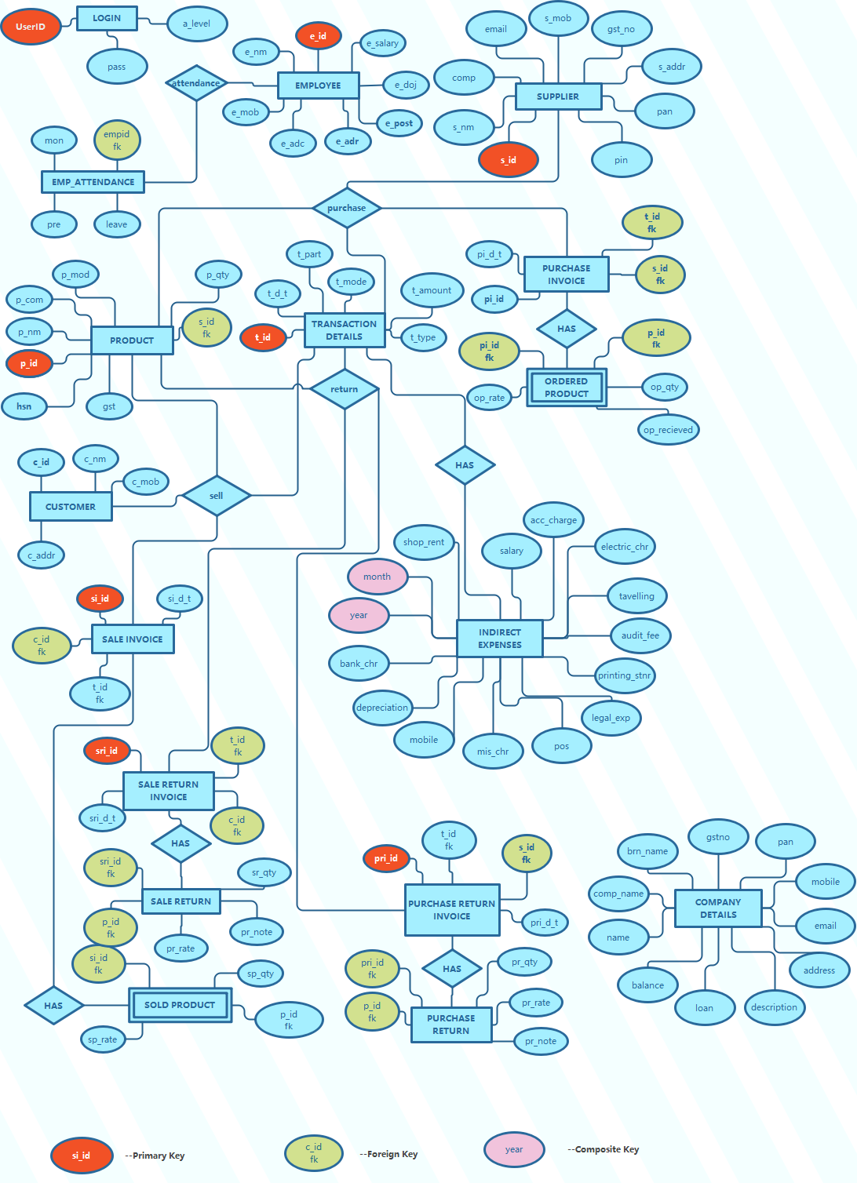
TABLE DESCRIPTION
- COMPANY DETAILS (ER_MASTER_COMPANY_DETAILS)

FIELDS | DATA TYPE | SIZE | CONSTRAINT | DEFAULT | DESCRIPTION
NAME | VARCHAR | 30 | NOT NULL |  | OWNER’S NAME
COMPANY_NAME | VARCHAR | 50 | NOT NULL |  | COMPANY NAME
BRANCH_NAME | VARCHAR | 30 | PRIMARY KEY |  | BRANCH NAME
GST | CHAR | 15 | NOT NULL |  | GST NUMBER
PAN | CHAR | 10 | NOT NULL |  | PAN CARD NUMBER
MOBILE_NO | CHAR | 10 | NOT NULL |  | MOBILE NUMBER
EMAIL | VARCHAR | 50 | NOT NULL |  | EMAIL ADDRESS
DESCRIPTION | VARCHAR | 100 | NULL |  | COMPANY DESCRIPTION

- ACCOUNT (ER_MASTER_ACCOUNT)
FIELDS | DATA TYPE | SIZE | CONSTRAINT | DEFAULT | DESCRIPTION
ACC_NO | CHAR | 5 | PRIMARY KEY  (PK_ACC) |  | IT IS JUST ID FOR THE TABLE
BALANCE | DECIMAL | 15,2 |  | 0 | TOTAL BALANCE
LOAN | DECIMAL | 15,2 |  | 0 | LOAN AMOUNT
INCOME | DECIMAL | 15,2 |  | 0 | TOTAL INCOME PER MONTH
EXPENSE | DECIMAL | 15,2 |  | 0 | TOTAL EXPENSE PER MONTH
MONTH | CHAR | 3 | NOT NULL |  | MONTHS

- TRANSACTION DETAILS (ER_MASTER_TRANSACTION)

FIELDS | DATA TYPE | SIZE | CONSTRAINT | DEFAULT | DESCRIPTION
T_ID | VARCHAR | 50 | PRIMARY KEY |  | TRANSACTION ID
T_DATE | CHAR | 10 | NOT NULL |  | DATE
T_TIME | CHAR | 8 | NOT NULL |  | TIME
T_PAR | VARCHAR | 50 | NOT NULL |  | REASON FOR TRANSACTION
T_CR_DR | CHAR | 2 | NOT NULL |  | CREDIT OR DEBIT
T_MODE | VARCHAR | 10 | NOT NULL |  | CASH OR CARD OR CHEQUE
T_AMOUNT | DECIMAL | 15,2 |  | 0 | TRANSACTION AMOUNT

- LOGIN (ER_MASTER_LOGIN)

FIELDS | DATA TYPE | SIZE | CONSTRAINT | DEFAULT | DESCRIPTION
USERID | CHAR | 20 | PRIMARY KEY |  | LOGIN ID
PASSWORD | VARCHAR | 20 | NOT NULL |  | PASSWORD
ACCESS_LEVEL | CHAR | 2 | NOT NULL |  | PRIVILEGES TO USER

- EMPLOYEE (ER_MASTER_ EMPLOYEE)

FIELDS | DATA TYPE | SIZE | CONSTRAINT | DEFAULT | DESCRIPTION
E_ID | CHAR | 10 | PRIMARY KEY |  | EMPLOYEE ID
E_NAME | VARCHAR | 30 | NOT NULL |  | NAME
E_FNAME | VARCHAR | 30 | NOT NULL |  | FATHERS NAME
E_DOB | CHAR | 10 | NOT NULL |  | DATE OF BIRTH
E_GEN | CHAR | 1 | NOT NULL |  | GENDER
E_MOB | CHAR | 10 | NOT NULL |  | MOBILE NO.
E_EMAIL | VARCHAR | 50 | NULL |  | EMAILS
E_ADHAAR | CHAR | 16 | NOT NULL |  | ADHAAR CARD
E_DOJ | DATE |  | NOT NULL |  | DATE OF JOINING
E_ADD | VARCHAR | 100 | NOT NULL |  | ADDRESS
E_QUL | VARCHAR | 30 | NOT NULL |  | QUALIFICATION
E_EXP | CHAR | 2 | NOT NULL |  | EXPERIENCE OF WORKING
E_POST | VARCHAR | 30 | NOT NULL |  | POSITION OF EMPLOYEE
E_LEAVE | CHAR | 1 | NOT NULL |  | MAX LEAVE PER MON
E_SALARY | DECIMAL | 5 |  | 0 | SALARY

- EMPLOYEE ATTENDANCE (ER_SUB_ATTENDANCE)
FIELDS | DATA TYPE | SIZE | CONSTRAINT | DEFAULT | DESCRIPTION
E_ID | CHAR | 10 | FOREIGN KEY (FK_EA_E_ID) |  | EMPLOYEE ID LINK TO EMPLOYEE TABLE
MONTH | CHAR | 3 | NOT NULL |  | MONTH
PRESENT | NUMBER | 2 | NOT NULL |  | TOTAL PRESENT
LEAVE | NUMBER | 2 | NOT NULL |  | ABSENT
- SUPPLIER (ER_MASTER_SUPPLIER)

FIELDS | DATA TYPE | SIZE | CONSTRAINT | DEFAULT | DESCRIPTION
S_ID | CHAR | 10 | PRIMARY KEY (PK_S_ID) |  | SUPPLIER ID
S_NAME | VARCHAR | 30 | NOT NULL |  | NAME
COMPANY_NAME | VARCHAR | 50 | NOT NULL |  | COMPANY NAME
S_EMAIL | VARCHAR | 30 | NOT NULL |  | EMAIL
S_MOBILE | CHAR | 10 | NOT NULL |  | MOBILE NO.
S_GSTNO | CHAR | 15 | NOT NULL |  | GST NO.
S_PAN | CHAR | 10 | NOT NULL |  | PAN CARD NO.
S_ADDRESS | VARCHAR | 100 | NOT NULL |  | ADDRESS
S_PINCODE | CHAR | 6 | NOT NULL |  | PINCODE

- PRODUCT (ER_MASTER_PRODUCT)

FIELDS | DATA TYPE | SIZE | CONSTRAINT | DEFAULT | DESCRIPTION
P_ID | VARCHAR | 15 | PRIMARY KEY (PK_P_ID) |  | PRODUCT ID
P_NAME | VARCHAR | 100 | NOT NULL |  | NAME
P_COMPANY | VARCHAR | 50 | NOT NULL |  | COMPANY NAME
P_MODEL | VARCHAR | 20 | NOT NULL |  | MODEL NO.
HSN | CHAR | 8 | NOT NULL |  | HSN CODE
P_GST | DECIMAL | 4,2 | NOT NULL |  | TAX %
P_QTY | NUMBER | 2 | NOT NULL | 0 | QUANTITY
S_ID | CHAR | 10 | FOREIGN KEY (FK_P_S_ID) |  | IT IS LINKED TO THE SUPPLIER

- PURCHASE INVOICE(ER_MASTER_PURCHASE_INVOICE)

FIELDS | DATA TYPE | SIZE | CONSTRAINT | DEFAULT | DESCRIPTION
PI_ID | VARCHAR | 20 | PRIMARY KEY (PK_PI_ID) |  | PURCHASE INVOICE ID
PI_DATE_TIME | VARCHAR | 20 | NOT NULL |  | DATE OR TIME
S_ID | CHAR | 10 | FOREIGN KEY (FK_PI_S_ID) |  | LINK TO SUPPLIER

- ORDERED PRODUCT (ER_MASTER_ORDERED_PRODUCT)

FIELDS | DATA TYPE | SIZE | CONSTRAINT | DEFAULT | DESCRIPTION
PI_ID | VARCHAR | 20 | FOREIGN  (FK_OP_PI_ID) |  | LINK TO PURCHASE INVOICE
P_ID | VARCHAR | 15 | FOREIGN  (FK_OP_P_ID) |  | LINK TO PRODUCT
OP_RATE | DECIMAL | 7,2 | NOT NULL |  | RATE OF PRODUCT
OP_QTY | NUMBER | 2 | NOT NULL |  | QUANTITY OF PRODUCT
OP_STATUS | VARCHAR | 15 | NOT NULL |  | STATUS OF PRODUCT

- ORDER RECEIVED (ER_MASTER_ORDER_RECEIVED)
FIELDS | DATA TYPE | SIZE | CONSTRAINT | DEFAULT | DESCRIPTION
PI_ID | VARCHAR | 20 | FOREIGN KEY (FK_OR_PI_ID) |  | PURCHASE INVOICE ID
P_ID | VARCHAR | 15 | FOREIGN KEY  (FK_OR_P_ID)
OR_QTY | NUMBER | 2 |  | 0

- STOCK (ER_SUB_STOCK)
FIELDS | DATA TYPE | SIZE | CONSTRAINT | DEFAULT | DESCRIPTION
P_ID | VARCHAR | 15 | FOREIGN KEY  (FK_OR_P_ID)
OR_QTY | NUMBER | 2 |  | 0

- CUSTOMER (ER_MASTER_CUSTOMER)

FIELDS | DATA TYPE | SIZE | CONSTRAINT | DEFAULT | DESCRIPTION
C_ID | VARCHAR | 10 | PRIMARY KEY  (PK_C_ID) |  | CUSTOMER ID
C_NAME | VARCHAR | 30 | NOT NULL |  | CUSTOMER’S NAME
C_MOBILE | CHAR | 10 | UNIQUE NOT NULL |  | MOBILE NO.
C_EMAIL | VARCHAR | 50 |  |  | EMAIL ADDRESS
C_ADDR | VARCHAR | 100 | NOT NULL |  | ADDRESS OF CUSTOMER

- SELL INVOICE (ER_MASTER_SELL INVOICE)

FIELDS | DATA TYPE | SIZE | CONSTRAINT | DEFAULT | DESCRIPTION
SI_ID | VARCHAR | 30 | PRIMARY KEY  (PK_SI_ID) |  | SELL INVOICE ID
C_ID | VARCHAR | 10 | FOREIGN  (FK_SI_C_ID) |  | LINK TO CUSTOMER
T_ID | VARCHAR | 50 | FOREIGN  (FK_SI_T_ID) |  | LINK TO TRANSACTION
SI_DATE_TIME | VARCHAR | 20 | NOT NULL

- SOLD PRODUCT (ER_SUB_SOLD_PRODUCT)

FIELDS | DATA TYPE | SIZE | CONSTRAINT | DEFAULT | DESCRIPTION
SI_ID | VARCHAR | 30 | FOREIGN KEY  (FK_SP_SI_ID) |  | LINK TO SELL INVOICE
P_ID | VARCHAR | 15 | FOREIGN KEY  (FK_SP_P_ID) |  | LINK TO PRODUCT
SP_QTY | NUMBER | 2 | NOT NULL |  | QUANTITY OF PRODUCT
SP_RATE | DECIMAL | 7,2 | NOT NULL |  | RATE OF PRODUCT

- SALE RETURN INVOICE (ER_MASTER_SALE_RETURN_INVOICE)

FIELDS | DATA TYPE | SIZE | CONSTRAINT | DEFAULT | DESCRIPTION
SRI_ID | VARCHAR | 30 | PRIMARY_KEY  (PK_SRI_ID) |  | SALE RETURN INVOICE ID
SI_ID | VARCHAR | 30 | FOREIGN KEY  (FK_SRI_SI_ID) |  | LINK TO SELL INVOICE
C_ID | VARCHAR | 10 | FOREIGN KEY  (FK_SRI_C_ID) |  | LINKED TO CUSTOMER
T_ID | VARCHAR | 50 | FOREIGN KEY  (FK_SRI_T_ID) |  | LINKED TO TRANSACTION
SRI_DATE_TIME | VARCHAR | 20 | NOT NULL |  | DATE & TIME

- SALE RETURN(ER_SUB_SALE_RETURN)

FIELDS | DATA TYPE | SIZE | CONSTRAINT | DEFAULT | DESCRIPTION
SRI_ID | VARCHAR | 30 | FOREIGN KEY  (FK_SR_SRI_ID) |  | LINK TO SALE RETURN INVOICE
P_ID | VARCHAR | 15 | FOREIGN KEY  (FK_SR_P_ID) |  | LINK TO PRODUCT
SR_QTY | NUMBER | 2 | NOT NULL |  | QUANTITY OF PRODUCT
SR_RATE | DECIMAL | 7,2 | NOT NULL |  | RATE OF PRODUCT PER UNIT
SR_NOTE | VARCHAR | 50 | NOT NULL |  | REASON FOR RETURN

- PURCHASE RETURN INVOICE(ER_MASTER_PUR_RETURN_INVOICE)

FIELDS | DATA TYPE | SIZE | CONSTRAINT | DEFAULT | DESCRIPTION
PRI_ID | VARCHAR | 30 | PRIMARY KEY  (PK_PRI_ID) |  | PURCHASE RETURN INVOICE ID
S_ID | CHAR | 10 | FOREIGN KEY  (FK_PRI_S_ID) |  | LINKED TO SUPPLIER
T_ID | VARCHAR | 50 | FOREIGN KEY  (FK_PRI_T_ID) |  | LINKED TO TRANSACTION
PRI_DATE_TIME | VARCHAR | 20 | NOT NULL |  | DATE & TIME

- PURCHASE RETURN (ER_SUB _PURCHASE_RETURN)

FIELDS | DATA TYPE | SIZE | CONSTRAINT | DEFAULT | DESCRIPTION
PRI_ID | VARCHAR | 30 | FOREIGN KEY  (FK_PR_PRI_ID) |  | LINKED TO PURCHASE RETURN INVOICE
P_ID | VARCHAR | 15 | FOREIGN KEY  (FK_PR_P_ID) |  | LINKED TO PRODUCT
PR_QTY | NUMBER | 2 | NOT NULL |  | QUANTITY OF PRODUCT
PR_RATE | DECIMAL | 7,2 | NOT NULL |  | RATE OF PRODUCT PER UNIT
PR_NOTE | VARCHAR | 50 | NOT NULL |  | REASON FOR RETURN

- INDIRECT EXPENSES (ER_MASTER_INDIRECT_EXPENSES)

FIELDS | DATA TYPE | SIZE | CONSTRAINT | DEFAULT | DESCRIPTION
YEAR | CHAR | 4 | PRIMARY KEY  (PK_IE_YR_MON) |  | YEAR
MONTH | CHAR | 3 | PRIMARY KEY  (PK_IE_YR_MON) |  | MONTH
SHOP_RENT | DECIMAL | 7,2 |  | 0 | RENT OF SHOP
SALARY | DECIMAL | 8,2 |  | 0 | TOTAL SALARY AMOUNT
ACC_CHR | DECIMAL | 7,2 |  | 0 | ACCOUNT CHARGE
ELECTRIC_CHR | DECIMAL | 7,2 |  | 0 | ELECTRICITY CHARGE
TRAVEL | DECIMAL | 7,2 |  | 0 | TRAVELLING COST
AUDIT_FEE | DECIMAL | 7,2 |  | 0 | AUDIT FEE
PRINTING_STNR | DECIMAL | 7,2 |  | 0 | PRINTING AND STATIONARY COST
LEGAL_EXP | DECIMAL | 7,2 |  | 0 | LEGAL EXPENSES
POS | DECIMAL | 7,2 |  | 0 | POS CHARGE
MIS | DECIMAL | 7,2 |  | 0 | MISCELLANEOUS CHARGE
MOBILE | DECIMAL | 7,2 |  | 0 | MOBILE
DEPRECIATION | DECIMAL | 7,2 |  | 0 | DEPRECIATION
BANK_CHR | DECIMAL | 7,2 |  | 0 | BANK CHARGES

PROJECT PLANNING

PHASES | MEMBERS | TOTAL DAYS
- ANALYSIS  - DATA GATHERING  - FEASIBILITY STUDY  - COST-BENEFIT ANALYSIS  - PROJECT PROPOSAL | Amit Narayan  Saloni Kumari  Ashish Kumar  Ayush Pandey | Total 26 Days
- DESIGN | Amit Narayan  Saloni Kumari  Ashish Kumar | Total 7 Days
- CODING | Amit Narayan  Saloni Kumari  Ashish Kumar  Ayush Pandey | Total 16 Days
- TESTING | Amit Narayan  Saloni Kumari  Ashish Kumar  Ayush Pandey | Total 13 Days
- IMPLEMENTATION | Amit Narayan  Saloni Kumari  Ashish Kumar  Ayush Pandey | Total 3 Days
- DOCUMENTATION | Amit Narayan  Ashish Pandey | Total 60 days

Total Days: 65 days
FUTURE SCOPE OF THE PROJECT
If we talk about the next version of our software, we will provide certain features like:
- Product details with images
- Multiple billing simultaneously
- Graphs for representing Profit and loss

These features we will provide in our next version of software.

